Partition coefficient activity |  |  |  | Date
Name |  | Teacher

The following experiment was set up where iodine crystals were added to a flask containing a mixture of water and tetrachloromethane (CCl₄).
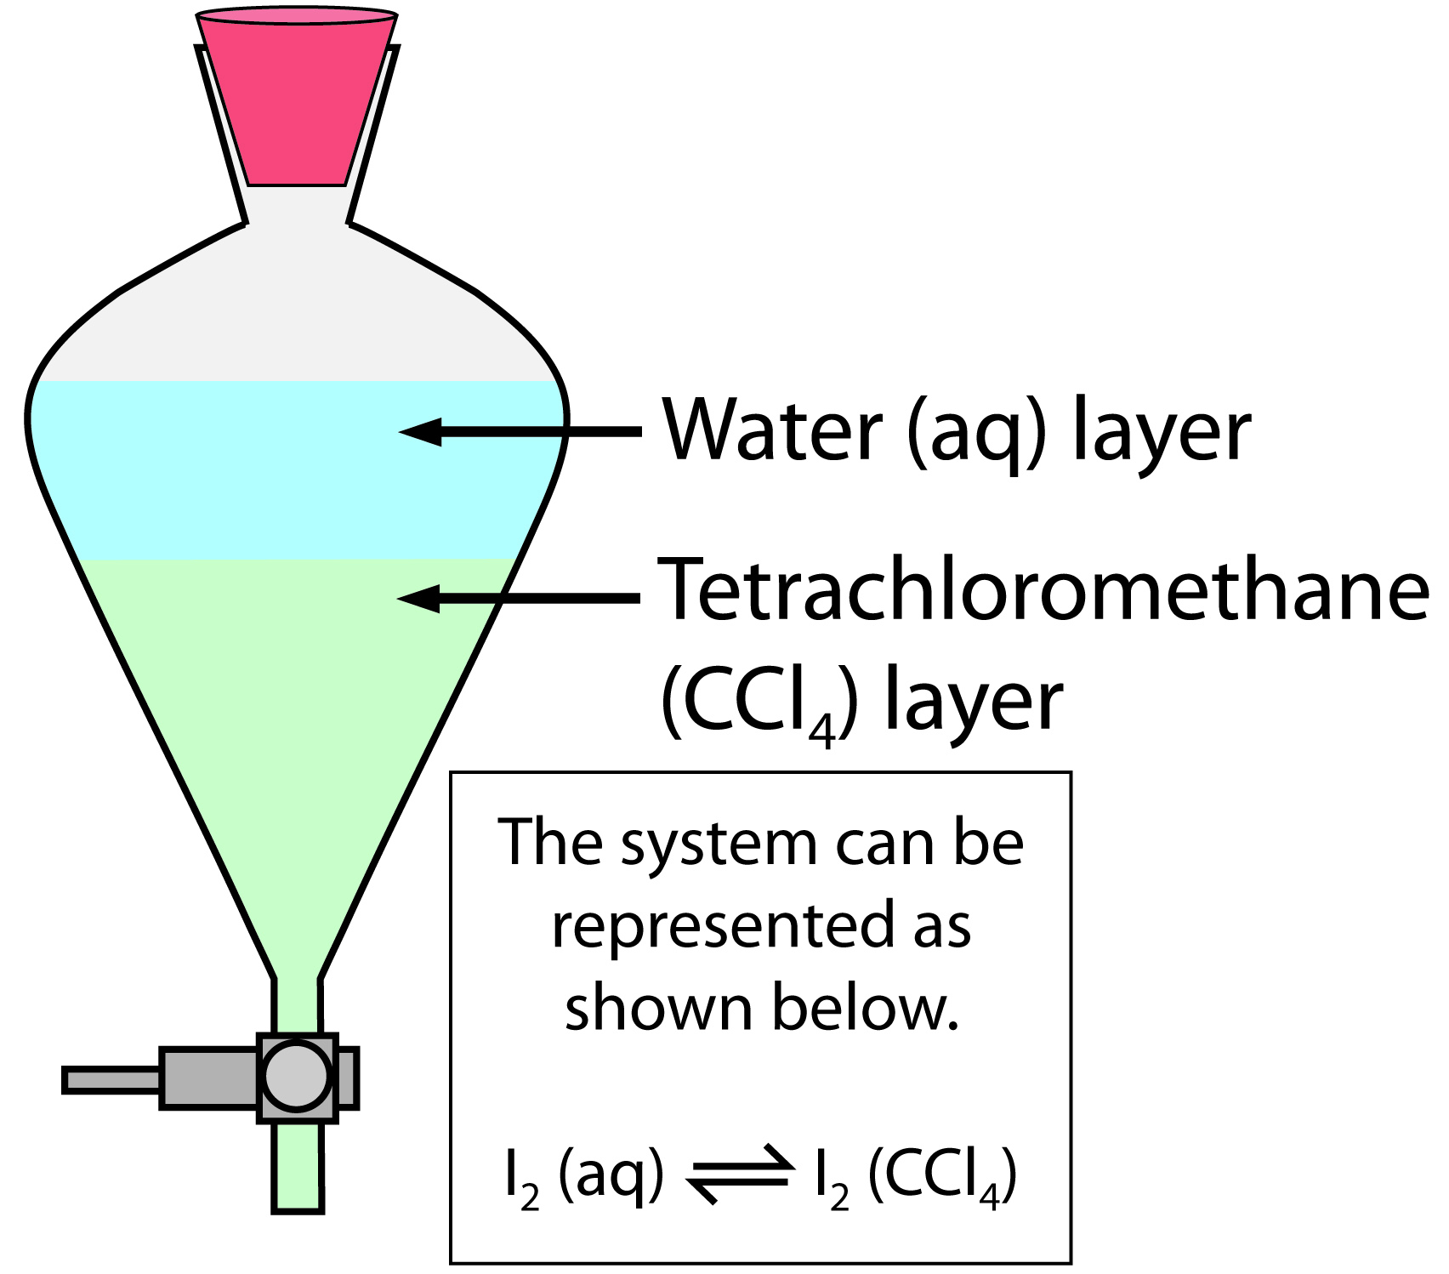
The flask was shaken, and after being allowed to settle, the concentrations of the iodine in the two solvents were measured. The test was repeated 4 times, each time varying the total amount of iodine used.

Results
Trial | Concentration of iodine [I₂] (mol L⁻¹)
 | [I₂] in water (aq) | [I₂] in tetrachloromethane (CCl₄)
1 | 6.38 ×10⁻³ | 0.530
2 | 1.30 ×10⁻² | 1.05
3 | 2.54 ×10⁻³ | 0.210
4 | 1.27 ×10⁻³ | 0.106

Analysis
1. The partition coefficient can be given by the following expression.
K =
Calculate the value of K for the four trials, and record them below.
Trial | Partition coefficient (K)
1
2
3
4
2. a) What do you notice about the calculated values for K in the trials?
b) Suggest a scientific explanation for your answer to a).

3. Explain what the calculated values of K in this experiment say about the solubility of iodine in water compared to its solubility in tetrachloromethane.

4. a) Iodine can be produced from seawater. Do you think that
tetrachloromethane would be a suitable solvent for extracting iodine from the seawater? Explain your answer.
b) Suggest how pure iodine could be obtained from the solution formed when it is dissolved in tetrachloromethane.
5. The partition coefficient (K) for chlorine (Cl₂) between the solvents tetrachloromethane and water has a value of approximately 10. Explain why this solvent would not be very efficient at extracting chlorine from water.

