In the balance: what do you know about equilibrium?

Tick the boxes that you are sure you are able to do. You must make sure that you are confident with the ones at the bottom. The more challenging concepts are higher up.

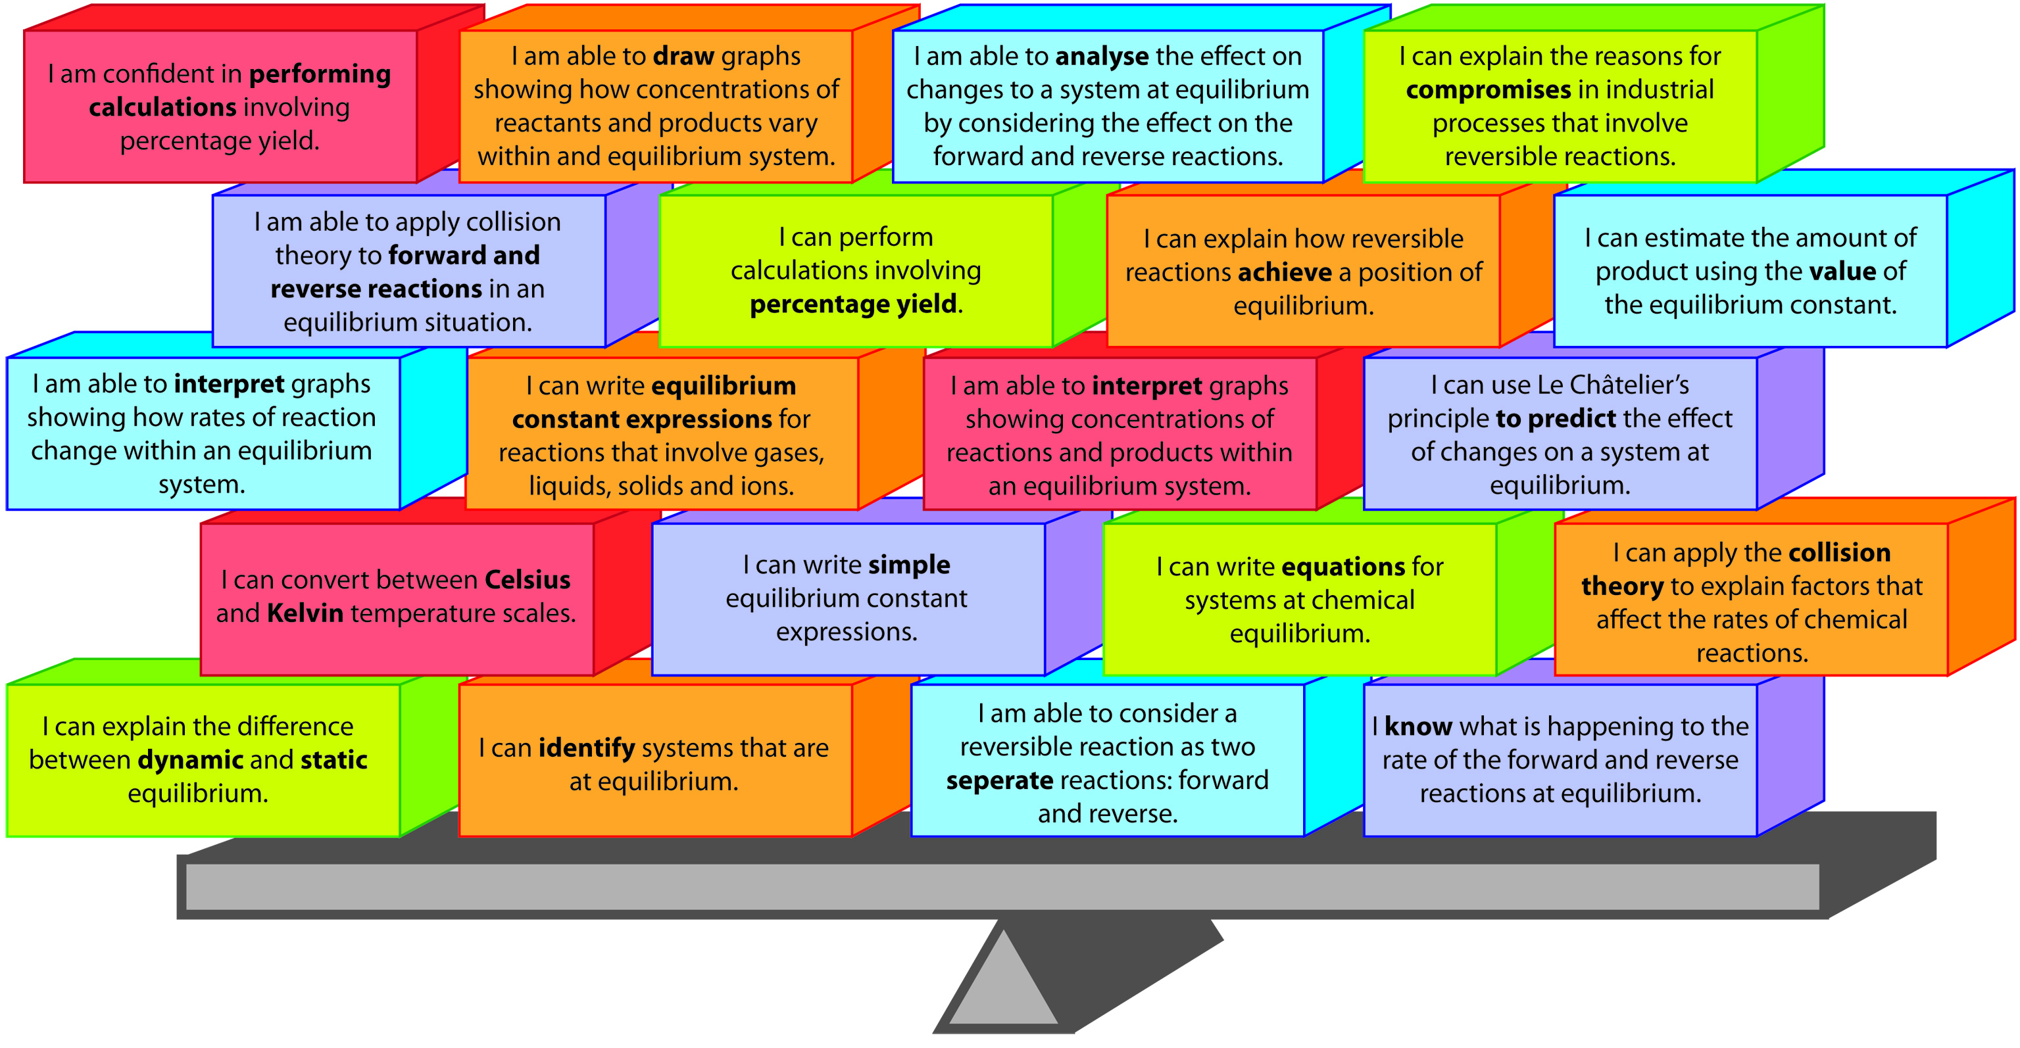
Which areas do you need to spend more time on?

