Storytelling Y-chart
Complete the Y-chart to show what a good storytelling session:
- looks like
- sounds like

- feels like.

You will need to think about this from the perspective of the storyteller AND the audience. You will need to clearly mark the ideas which apply to the teller and those that apply to the listener. To do this you could separate each section into two or use a different style or colour of font to distinguish between the listener and storyteller.
Sounds like What aspects of a performance will you hear? Of course, the voice … can you break this down into subsections? What other elements will you hear?
Looks like What can you see if you are in the audience? Is there anything that can enhance the performance visually? How will the storyteller look to the audience? Think about use of body language here. Is there anything else that could be on stage that may add to the telling?
If you are the storyteller, what will you see as you tell the story to the audience?
Feels like What would the story feel like from the audience’s perspective?
How would it feel to be telling the story – that is, from the storyteller’s perspective?

Complete the Y-chart on the next page.

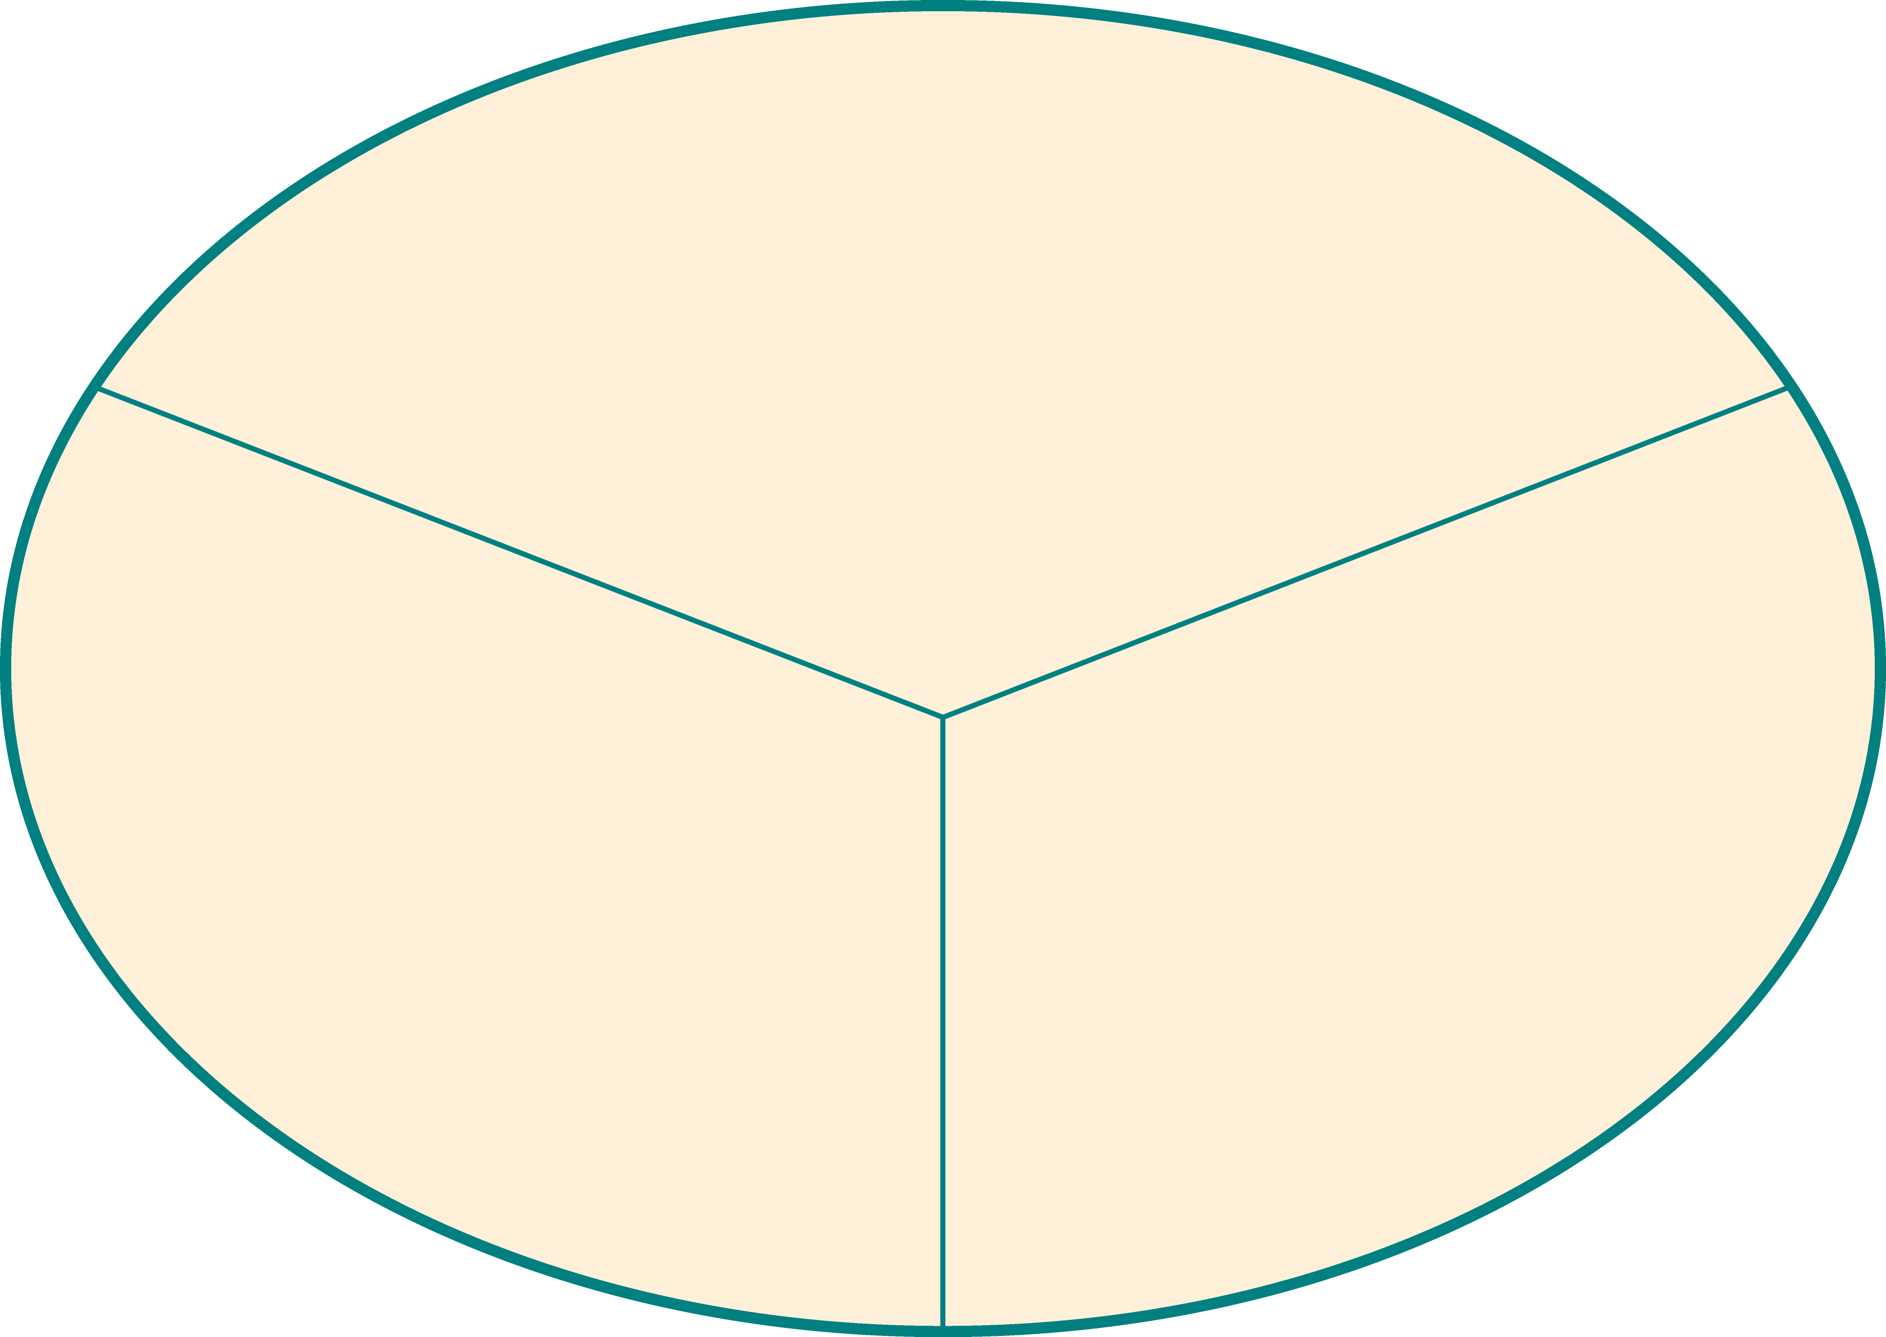
Storytelling Y-chart
